License No. of Manufacture Enterprise: Food & Drug Supervision Manufacturing License No.20000329
Product Standard Code: YZB/国 1169-2008 Edition 2011-10
Product Registration Number: SFDA 2008 No.3541211

Biohazard Safety Cabinet
BSC-1300ⅡA₂

Instruction Manual

SHANGHAI BOXUN INDUSTRY & COMMERCE CO., LTD. MEDICAL EQUIPMENT FACTORY
Content

Notes of warming tag and advice―――――――――――――――――― P1
Product introduction――――――――――――――――――――――― P2
- Product summary
- Applicable scope
- Main technical parameters
- Structure and feature of product
Principle of operation ―――――――――――――――――――――― P3
- Feature of product airflow
- Principle of product operation
Safety specification――――――――――――――――――――――― P4
- Requirement of biologic safety laboratory
- Operation and biologic safety
- Maintain and biologic safety
Installation of equipment――――――――――――――――――――― P4
- Installation conditions
- Installation methods
- Affirmance after installation
Notes of equipment function ――――――――――――――――――― P6
- Fan, HEAR and air filtration system
- Glideable front window
- Illumination
- Fan
- UV light
- Operation panel
- Notes of operation menu
Operation methods――――――――――――――――――――――― P8
- Preparation
- Operation
- Finish
Maintenance ――――――――――――――――――――――――― P8
- Sketch map of working zone and unprotected zone of safety cabinet
- Daily maintenance
- Maintenance and replacement of fan and HEAP
- Selection and use of disinfector
Disposal of malfunction――――――――――――――――――――― P9
- Judgement and disposal of malfunction
- After-sale service
Parameters table of main components―――――――――――――――― P10
Electric diagram of product―――――――――――――――――――― P10
Packing list―――――――――――――――――――――――――― P11

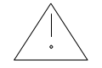You must read the instruction manual carefully before you use the equipment first time.
This sign is biohazard sign.
The biohazard safety cabinet only can be operated by the person who has reveived professional training or accredition.
The maintenance and repairment of biohazard safety cabinet must be opearted by our factory or agent.

Advice

The copyright of the instruction manual belongs to Shanghai Boxun Industry & Commerce Medical Equipment Factory. No re-press or diffuse of the instruction manual if unapproved.
The operator of the product can copy the instruction manual for inner use only.
If the operator of the product don’t operate according to the “Repuirement of safety use” and brings damnify of equipment and person, our company won’t have responsibility for it.
Product introduction
- Product summary
BSC-1300ⅡA₂ Biohazard safety cabinet is a negative pressure safety equipment which is widely applicable in microbiology, biomedicine, genic recombination, zoopery and biologicals. It is the basic safety protect equipment in laboratory biologic safety class one protect barrier which adopts advanced air clean technology and negative pressure cabinet design to achieve the protection for environment, person and sample.
- Applicable scope
BSC-1300ⅡA₂ Biohazard safety cabinet is a negative pressure draft cabinet which adopts ULPA and negative pressure cabinet structure. It is applicable in laboratory whose biologic safety class 1 to 3 for experiment of biohazard group 2-3. It is applicable in biologic experiment which the additive is microcrystalline volatility poisonous chemical substances or capacitated radioactive nuclide.
- Main technical parameters
  - Down airflow velocities: 0.35m/s;
  - Inflow airflow velocities: 0.56m/s;
  - Working zone: 1300×505×640;
  - Overall dim.: 1420×860×1585 (not include bracket);
  - Average illuminance: over 650lx;
  - Noise: ≤67dB;
  - Vibration: ≤5µm;
  - Working power supply: ~220V 50Hz;
  - Consumption: 1400W (include power sockets)
  - Safety sort: Sort I
- Structure and feature of product
  - Structure
BSC-1300ⅡA₂ Biohazard safety cabinet is composed by cabinet case, bracket, fan, ULPA and control system. The case is made of 1.5mm thin cold-roll plate, and the chamber and the reservoir are made of SUS304 stainless steel palte. The double layers structure between the chamber and the ektexine of the cabinet is the air duct. The fan adopts imported fan, and it composes the air cycle system with ULPA and negative pressure air duct. And a whole system of safety cabinet is composed under the control system composed with microcomputer CMOS chip controlled. The follow sketch map is the main structure:
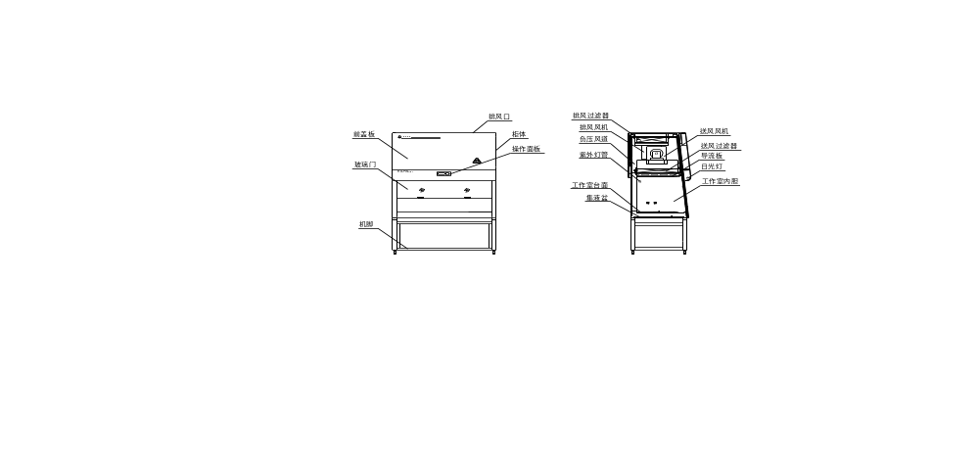

Sketch map of product
  - Feature
- Adopts touch-type control screen and controller with microcomputer technology. It can control the air speed, differential pressure and height of work window accurately to ensure the safe operation;
- Adopts ULPA to filtrate the air effectively to protect environment and sample;
- Working zone is surrounded with negative pressure air duct to ensure the safe operation;
- Touch-type control screen adopts LCD screen which can displays various parameters and operation menu such as air speed, differential pressure and time to make the operation convenient and intuitionistic.
- Operaion zone and reservoir are made of stainless steel plate with arc angle. It’s equipped with the let valve on the bottom of the reservoir for easy clean and disinfection.
Principle of operation
- Feature of product airflow:
BSC-1300ⅡA₂ Biohazard safety cabinet is a negative pressure safety equipment which can supply proctection for user, environment and sample. It has features as follows:
- Keep the min.average inhalational air speed which through the open side of working table to 0.5m/s (calculated value or measured value);
- The vertical airflow filtrated by HEPA is the part of mixed airflow of vertical airflow let from static pressure box and inhalational airflow;
- All air after filtrated can be let indoor or outdoor;
- All biohazard air duct and static pressure box should be kept negative pressure or surrounded with negative pressure air duct and static pressure box.
Under the drive of the built-in fan, the operation opening of A₂ Biohazard safety cabinet come into being inflow airflow. It is mixed with the part of polluted airflow in negative pressure chamber. Part is filtrated through blast filter and come into being vertical drop airflow and enter working chamber, other part is filtrated through discharge air filter and let out of the cabinet. Airflow mode is indicated as follows.
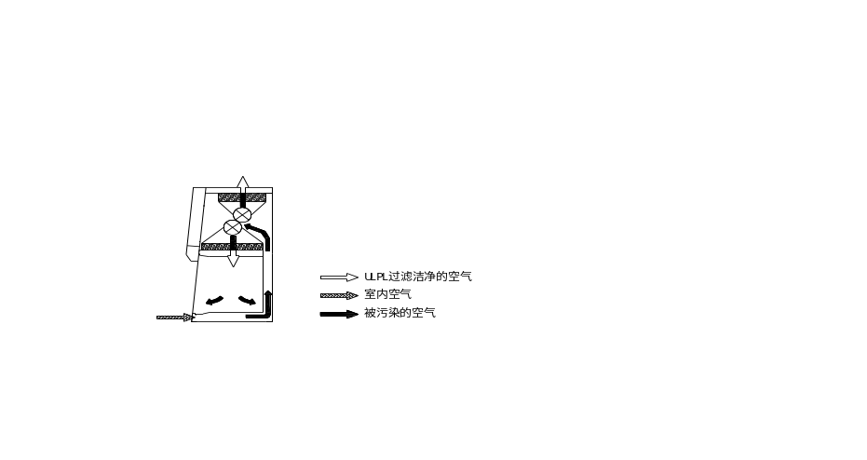
Airflow mode of A₂ Biohazard safety cabinet
- Principle of product operation
When the cabinet is running, negative pressure is formed by air exhausted by the built-in fan. Equal air is imbibed into the operation area grids and an airflow whose speed is greater than 0.5m/s (academic or measured airflow speed) is formed at the operation aperture. Imbibed air is mixed with intrinsic circular air in negative pressure air duct, and taken to static pressure box by fan and filtrated by blast HEPA, then vertical flow clean air is supplied to operation area. Vertical airflow from above to below is divided into two parts when it is near the working table. Part is drawn out through front grids, other is drawn out through front grids. The two parts of circular airflow are mixed with inhalational air, and reach the place between blast filter and exhaust filter through air duct. 30% of air is exhausted through HEPA and 70% of air is sent to operation area in virtue of the difference of relative size of two HEPAs. Through the continual running of fan, constant negative pressure is formed in air duct to prevent leakage of polluted air.
Safety specification
- Requirement of biologic safety laboratory
As the basal safety protection equipment in biohazard, the safe use of safety cabinet has follow requirements of laboratory:
  - Select corresponding level and sort safety cabinet according to the biohazard safety rank;
  - Biohazard safety laboratory should supply suitable fabricating yard and supporting facilities;
  - Corresponding management system and safe operation criterion are necessary to ensure the safe use.
  - Laboratory should validate and appraise the security after first installation and any move or repaire.
- Operation and biologic safety
Correct operation method is a important way to ensure biohazard safety, so follow content should be noticed:
  - Evaluate biohazard safety of sample, and operation must be carried on after effective evaluation is passed.
  - Don’t move the window exceed safety height when operating to protect user. The exhaust aperture on the top should be kept free.
  - No naked flame and high press air in the cabinet, otherwise it will affect inflow airflow and the protection for sample.
  - Put the instruments and sample into the cabinet all at one time before operation, and move the things slowly when operating.
  - No soft, fine things should be put on the working table when operating to avoid being imbibed into the negative pressure air duct or the fan to affect the running of the equipment.
  - All operation of aerosol brought by malgenic microorganism and its toxin should be carried on in the cabinet, and clean bench can’t replace by it.
- Maintain and biologic safety
  - Correct maintenance in daily use of safety cabinet is a important measure to ensure the biohazard safety. All maintenance should be supported by regulation programme and work instructor to ensure the validity of maintenance.
  - BSC-1300ⅡA2 Biohazard safety cabinet has marks of clean area and polluted area. The maintenance of these area is different. Especially, the maintenance of polluted area should be carried on in safe running to avoid dangerous aerosol overflow.
  - Report any malfunction when operating the safety cabinet, and turn off the equipment and appraise the reason of malfunction according to the dangerous accident processing program. It can be used after being maintained and appraised.
Installation of equipment
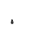Open the packing of BSC-1300ⅡA₂ Biohazard safety cabinet and take the instruction manual out. Install the cabinet according to the instruction manual.
- Installation conditions
  - Ambient temperature: 10℃～30℃, relative humidity: ≤70%;
  - Requirement of power supply: the capacity of power socket should be greater than 20A, otherwise the cabinet won’t have the protection function;
  - No vibration around and no direct sunlight;
  - Requirement of ambient: the ambient should meet the requirement of bio-laboratory from Class BSL-1 to Class BSL-3, and keep relevant constant temperature and humidity condition and cleanliness.
  - Aeration system: if BSC-1300ⅡA₂ Biohazard safety cabinet will be used in the microorganism experiment which adjuvant is atom volatile poisonous chemical and trace radioactive nuclide, the laboratory should equipped with aeration system.
  - The installation place of safety cabinet should be confirmed according to the process flow. Fixed power socket and gasol pipeline interface, and remain the distance over 200mm from the top of the cabinet to ensure the aeration free.
  - Don’t install the cabinet at the aisle or set the operation aperture against the door or window, otherwise the airflow will be damaged and do safety harm.
  - Keep a distance over 250cm for maintenance and operation when place the safety cabinet.
- Installation methods
  - The weight of the equipment reaches 300kg, so be careful when install it.
  - Don’t damage the seasl of the equipment when install it.
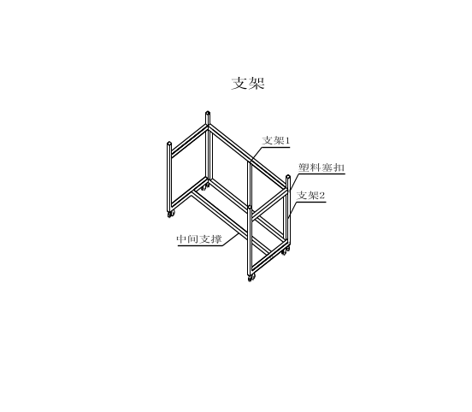(1) After open the packing, please check the cabinet and accessories according to the packing list, and install according to the follow diagram.
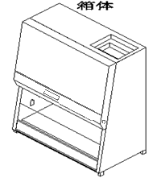

Diagram of safety cabinet installation strucure
(2) The safety cabinet is composed of case and bracket.
  - Fix the left and right brackets and the support of back bracket with M10 socket head screws.
  - Cove the apertures with plastic plugs. Raise the case to the bracket, aim the four fixed pegs on the bracket at the four fixed grooves at the bottom of the case, and put down vertical to finish the installation of cabinet.
  - If it need to be moved, adjust the fixed bolts on the bottom of the bracket to the position higher than wheels. After move, adjust to fix position.
  - Remove the fixed pegs on the working table (please keep them safely). Take out the fluorescent lamp and UV light, and install them in the front close plate and the workaround. (When install the fluorescent lamp, screwing out left and right two fixed bolts on the bottom of the front close plate, open the front close plate and install. After that, close it and screw in the fixed bolts.)
  - Connect the power supply with the fixed socket.
  - If gasol and TOF valve are necessary, screwing out the installation aperture on the back of the workaround and install all accessories. Debug after finished installation of valve.
- Affirmance after installation
After installation, safe use detection should be carried on according to specified procedure. And it can be used after checked out. Reference the follow installation detection items and apparatus or YY/0569-2005 Safety Cabinet Standard.
Installation item | Requirement | Method | Apparatus
Appearance | No scoring, rusty spot and impress, slick and smooth surface, complete and clear character and sign | Eyeballing | ——
Integrality of filter | Less than 0.01% of transmissivity | Launch aerosol at upper and detect at below | Aerosol generator, photometer
Downdraght speed  Inflow speed | Average of airflow speed less than rating±0.20m/s | 100mm higher than opening working zone and air outlet | Hot anemoscope, precision±3%
Airflow mode | Airflow in working zone should be downflow | Eyeballing | Smoke generator or atomization device
Notes of equipment function
- Fan, HEAR and air filtration system
Air filtration system of BSC-1300ⅡA₂ Biohazard safety cabinet is composed of drive fan, air duct, circular air filter and air outlet filter. The main function is let the clean air into the working zone and make the outlet air reach axenic and hurtless to avoid the environment pollution.
- Glideable front window
Glideable front window adopts safe glass, open height of working is 200mm. The safe height interlocking device is set, it will seperate the working zone and environment, and widen the sight of user.
- Illumination
The equipment adopts 2×40W straight cannulation type energy saving fluorescent lamp as the illumination lamp-house. Average of illuminance is higher than 650lx. It is installed at the inside of front cover plate, and beam can enter the working zone unreflectedly and softly.
- Fan
The circular air filtration system of the equipment forms the flow down airflow and inflow airflow are formed by drive fan. The fan is installed at the inside of the upper cabinet. The area is negative pressure area which is polluted, so the maintance of fan should be handle according to the relevant requirements.
- UV light
The UV light of the equipment is installed on the middle upside of back plate for the use of sterilization. To avoid ultraviolet radiation harm user when working, the interlocking device of safe use is set and it is controlled by the controller.
- Operation panel
The control panel of electric controller is at right underside of the front cover plate. The display screens and the operation buttons are showed as follow:

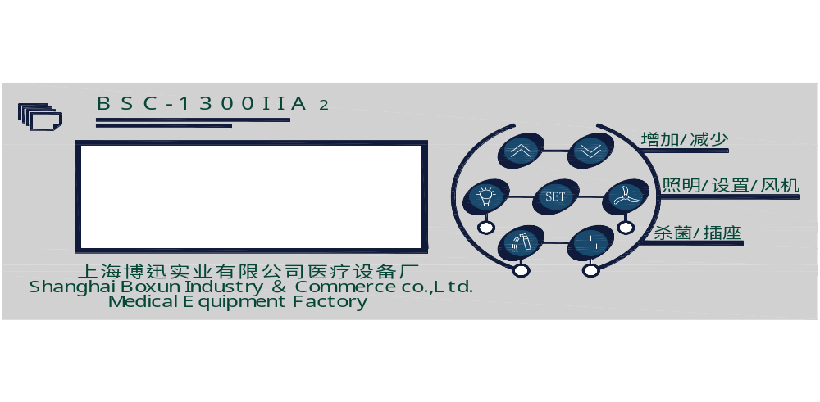

Sketch map of operation panel
    - Increase/Decrease: select the menu or increase/decrease the number
    - SET: enter the set menu
    - Operation: control the light, socket, fan and UV light
    - LCD screen: display the menu and working state
    - Alarm: display the alarm contect

7、Notes of operation menu
1）Switch on the power supply and turn on the whole equipment power switch;
2）LCD screen displays notes after about 3 sec:
- 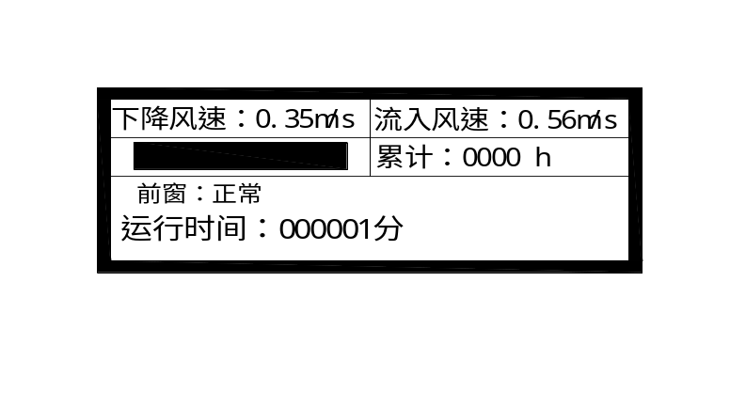Fall flow speed: 0.35m/s is fall flow speed in cabinet;
- Inflow speed: 0.56m/s is the flow speed
from outside to inside;
- Black oblong indicates the use life of
filter (please exchange filter if no life strip);
- Normal working indicates whole
equipment work state;
- Add up: 0000h add up the work time;
- Front window state indicates the state of
front window glass door;
图 5
3) Notes of operation buttons:
a) Press the illunimation button (if UV light is on, it will be off automatically) the indicator light and the illumination light will be on, press again and they will be off.
b) Press the socket button and the indicator light will be on, the socket will contain 220V electricity, press again and it won’t contain.
c) Press the fan button and the fan will start work after 30 sec, press again and the fan will be closed.
d) Press the UV light button and the indicator light and UV light will be on, press again and them will be off.
Operation methods
- Preparation
a) Wear exposure suit, headpiece, respirator, eyepatch, glove and other safety products according to the rank of laboratory;
b) Before work, clean the surface of table, wall and observaion window with 70% alcohol or 0.05% chloros, then clean it again with axenic water to clean out chlorin remained to reduce cross-infection in experiments;
c) Insert the plug into fixed socket and open the front window operation gap to height of 200mm. Start the exhaust fan first, then start safety cabinet fan and keep it running for 3-5 min to clean the air in cabinet. Put experimental materials into cabinet before work and adjust the height of chair to ensure that your face is on the top of window gap.
d) Close the drain valve at the bottom of cabinet before work.
- Operation
a) Stretch the hands into chamber slowly after operation begins.
b) Operation should be proceeded in the distance of 100mm from grilles.
c) Implement biosafety procedures strictly for decreasing overflow and aerosols in operation.
d) Avoid flame in operation to maintain the normal airflow in cabinet.
e) After operation ends, clean and sterilize the cover of goods before take them out, then sterilize the walls of chamber.
- End
a) After sterilize and dry the wall, keep the machine running for 3 to 5min for clean the air in cabinet.
b) Turn off the light and fan, then close the front window.
c) Deal with polluted goods and remove experimental materials according to the prescript.
Maintenance and repair
1. The daily maintenance of the safety cabinet should be in different ways according to the different areas. The key of maintenance and repair is clean and disinfection of the contaminated area.
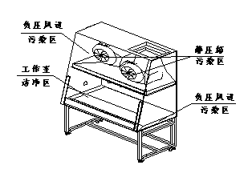
2. Routine maintenance
- Draw up the routine maintenance plan.
- Clean the operation area before and after each operation to ensure the normal use.
- If splash happens in operation, clean with bibulous paper towel in time, and take it into biology danger sterilization bag. Clean should be taken place in the running state.
- Clean the surface of UV light every week.
- After install and use for a period, confirm the entire running performances according to the prescriptive programme by professional.
- Maintain and exchange fan and HEPA
The fan and HEPA of BSC-1300ⅡA₂ are installed at the negative pressure cavity where is polluted area. Open the front cover plate after clean, then maintain and exchange the HEPA.
a) Exchange HEPA
After cleaned polluted area, exchange filter as follow steps:
- Clean the sealant around the front cover plate, unload the screws then open the front cover plate.
- Unload the fixed screws of filters, and take them out.
- Take the new filters to original place and screw.
- Fit the front cover plate and screw, and seal the plate with sealant.
b) Exchange fan
The preparation of exhanging fan is as same as exchanging HEPA.
- Unload the line of fan.
- Unload bolts of interface of air outlet and static pressure box.
- Loose the seven screws of fan.
- Unload the fan.
- Exchange the new fan, then fix as the same sequence.
- Fix the static pressure box and fan.
- Connect the power of fan and place the front cover plate with sealant.
Confirm according to the programme after changed HEPA and fan.
- Disinfection methods and selection and use of disinfectant
a) Disinfection of surface of chamber and opreation tools
Disinfect and clean the surface of chamber and operation tools and experimental containers before and after each operation. 70% ethanol or 0.05% sodium hypochlorite solution is used for disinfection to clean the surface, all the containers may have been contaminated can not be removed before surface disinfection is not carried out, the contaminated material should be placed in sealed containers and transferred to incubator or sterilizer for disinfection.
b) Disinfection of whole machine
Disinfect and purificate safety cabinet before exchange filter and daily maintenance. And a risk assessment of pathogens should be carried out before replace the cabinet, to decide whether to disinfect. The most common method is the use of formaldehyde fumigation of steam sterilization, it can decontaminate and disinfect contaminated air duct system and filters effectively. Fumigation should be carried out by a profession when the cabinet is closed.
Main disinfectant of fumigation disinfection method: formalin (paraformaldehyde) neutralizer used for ammonia (ammonium bicarbonate). Specific operations in accordance with Appendix B of YY0569.
Malfunction disposal
1. Malfunction judgement and disposal
It is safe when the cabinet is in normal use. If malfunction happenes in operation, especially fan and filter, take measures in time.
Malfunction phenomenon | Reason | Solution | Remark
1. Fan doesn’t work, but the fan indicate light is on | Control panel is broken | Open the front window to allowed height
1. Fan doesn’t work, but the fan indicate light is on | Fan is broken | Stop the machine for some time
2. Daylight lamp or UV light isn’t on | Poor contact of light feet | Adjust the light feet
2. Daylight lamp or UV light isn’t on | Barretter is broken | Exchange the barretter
2. Daylight lamp or UV light isn’t on | Light is broken | Exchange the light
3. Alarm continuously with sound and light | Filter is in invalidation | Exchange the filter | Safety check
3. Alarm continuously with sound and light | Front window isn’t at the safe place | Move the front window to safe place | Safety check
3. Alarm continuously with sound and light | Exhaust surface is jammed | Clean the exhaust surface | Safety check
3. Alarm continuously with sound and light | Sensor is abnormal | Exchange the sensor | Safety check
4. No power | Fuse is broken | Exchange the fuse
- When malfunction happenes, stop the operation and keep the fan works. proper dispose the materails and tools, and notify the maintenance department to come to dispose.
- Record the malfunction situations.
2. After-sale service
When malfunction happens, user can contact us through follow contact way.
Main parts parameter table
Parameter Table
No. | Name | Size | Quantity | Remark
1 | Wind sending filter | 1326×606×70(mm) | 1 | HEPA or ULPA≥99.99%
2 | Wind exhaust filter | 840×450×90(mm) | 1 | HEPA or ULPA≥99.99%
3 | Daylight lamp | 250V/40W | 1
4 | UV light | 250V/30W | 1
5 | Barretter | YZ-136EAA | 2
6 | Fan | EBM D4E225-CC01-02 | 1
7 | Fuse | F6A | 2 | Φ6×30
E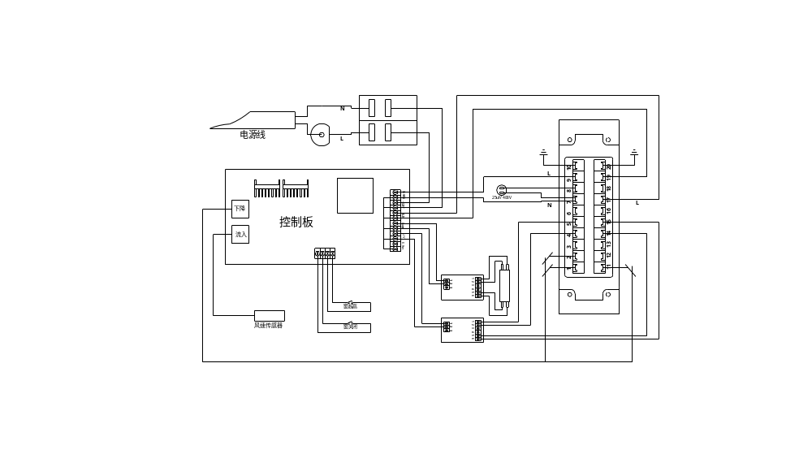lectric diagram

1300IIA₂ Biohazard Safety Cabinet
Packing List

No. | Name | Quantity | Remark
1 | Machine | 1 set
2 | Instruction manual | 1 pc
3 | Certificate of approval | 1 pc
4 | Quality warranty card | 1 pc
5 | Rack | 1 set
6 | Inner hexagon spanner | 1 pc
7 | Buckle choke plug | 8 pcs



Shanghai Boxun Industry & Commerce Co.,Ltd
Medical Equipment Factory

HQ Sale Address：F 9, No.198, North ZhongShan Rd., (ShenHang Building), Shanghai of China
HQ Tel：021-56980111 Fax：021-56303876
Sale Department：021-56980111 transfer each extension

Produce Base：No.28, ZhongQiang Rd., MaoGang Town, SongJiang District, Shanghai
Tel：021-57866102 Fax：021-57866198
After-sale Service Tel：021-57866322 021-57866248
After-sale Service Fax：021-57866155
Post Code：201607

Website：www.boxun.com.cn
E-mail：bx99123@163.com

